**Day 34:**

**Spring boot with Apache Kafka**

Apache Kafka : Apache Kafka is an open source software platform provided by Apache organization. Apache Kafka internally use Java and Scala language. Apache Kafka mainly use distributed message concept using pub and sub.

In Apache Kafka data is very huge, zero fault tolerance, Apache Kafka use stream concept to share data between one application to another application. It use sharing the data between one application to another application in asynchronous manner.

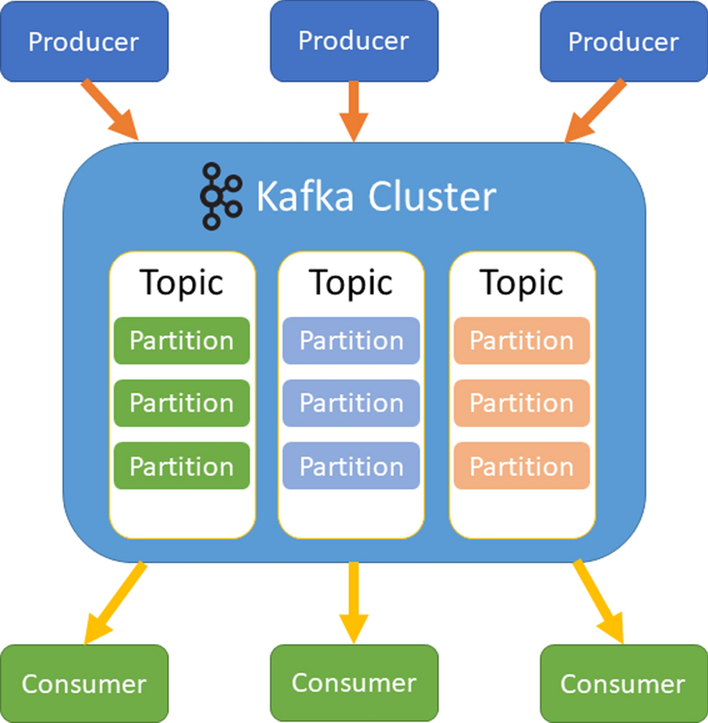

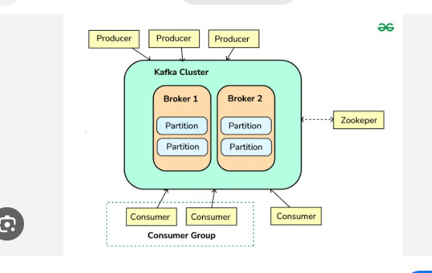

<https://kafka.apache.org/downloads>

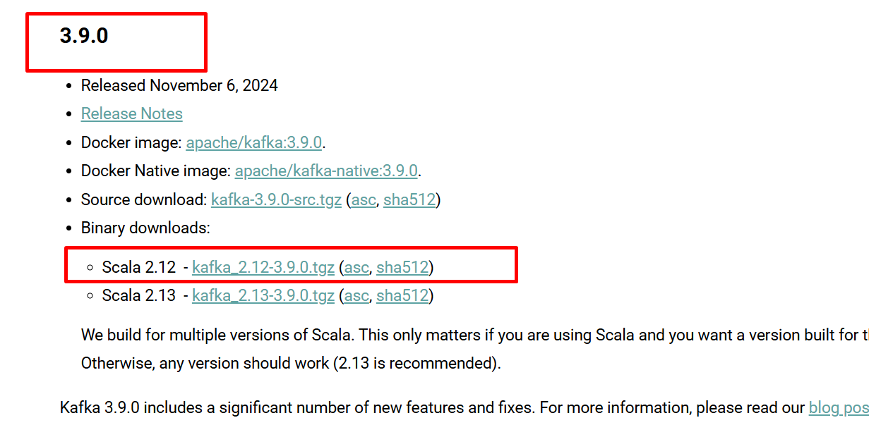

Open the command prompt inside a window folder of Apache Kafka server and run below command

Role of zookeeper is maintain Apache Kafka cluster environment

Below command is use to run the zookeeper

zookeeper-server-start.bat .\..\..\config\zookeeper.properties

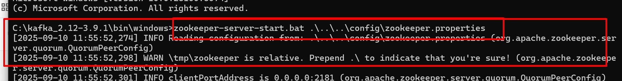

It run on default port number 2181.

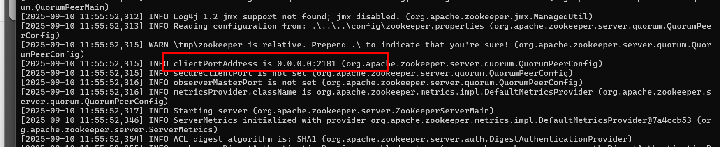

Now we need to start Apache Kafka Server

Open another command prompt

Run this command inside a window folder.

kafka-server-start.bat .\..\..\config\server.properties

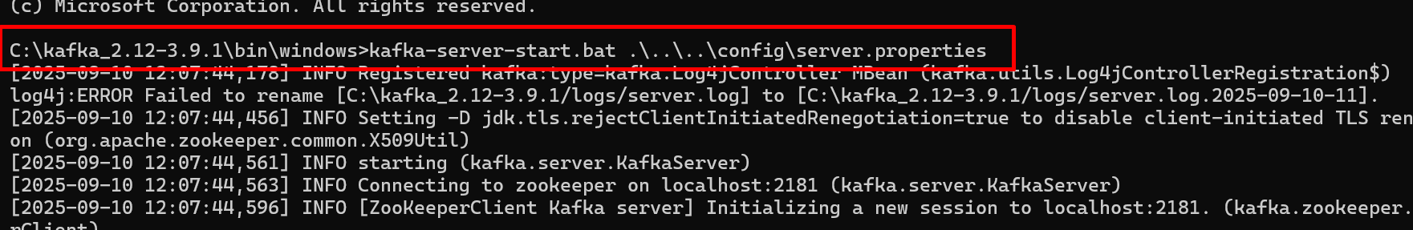

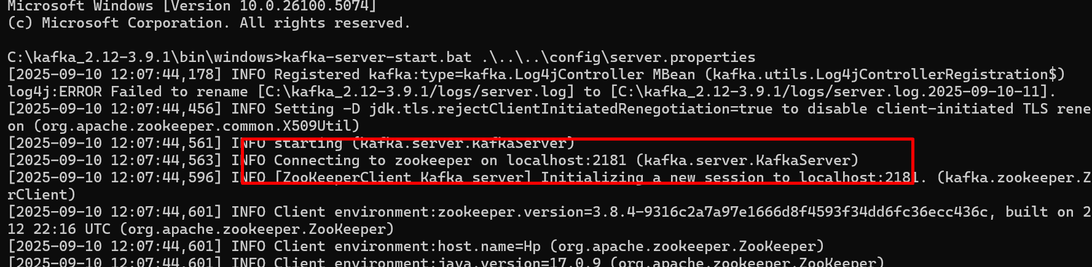

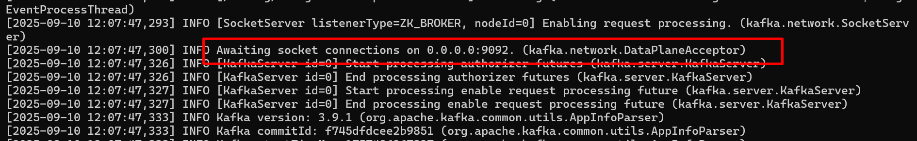

Apache Kafka Server run on port number 9092

Producer : A producer is a program using any language which connect to Apache Kafka server using hostname (localhost) with port number. It is use to send the any of data.

Consumer : A consumer is a program using any language which connect to Apache Kafka server using hostname(localhost) with port number. It is use to receive the message. We can run many consumer application

Topic: Topic is a type of container which hold the messages. Topic can split the message into n number partition for stability.

Broker : Insider Apache Kafka Server we can run more than one broker. Broker is responsible to hold more than one topic.

Zookeeper : it is a type service or server responsible to maintain the Apace Kafka cluster environment and broker file.

Creating the topic

kafka-topics.bat --bootstrap-server localhost:9092 --create --topic mytopic

view all topics present in default Broker

kafka-topics.bat --bootstrap-server localhost:9092 --list

this command is use to consume data from particular topic

kafka-console-consumer.bat --bootstrap-server localhost:9092 --topic mytopic

this command is use to produce data to particular topic

kafka-console-producer.bat --bootstrap-server localhost:9092 --topic mytopic

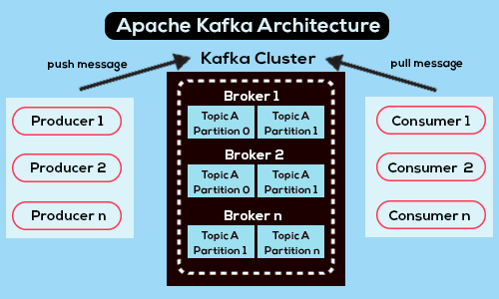

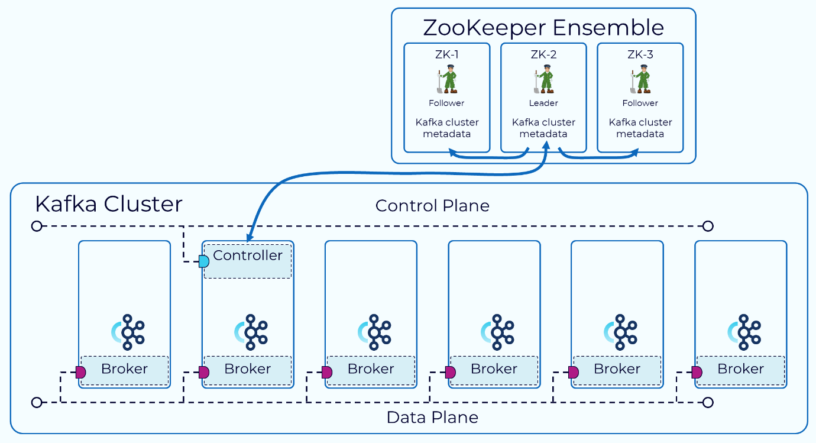

Creating Apache Kafka consumer example

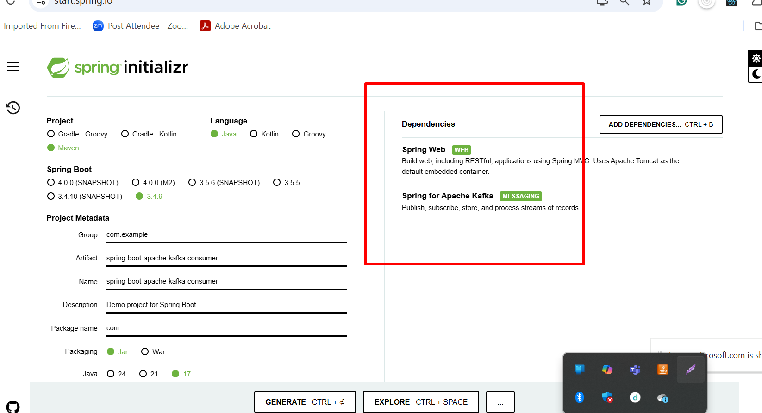

**Creating spring boot producer example**